Part A: Review
Question 1
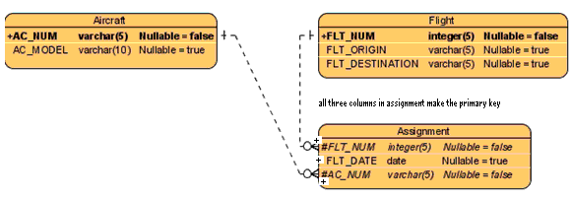
a) Are the relationships in this ERD strong or weak?
The relationships in this ERD are strong because:
• Aircraft and Flight are owners of Assignment
• Assignment is a weak entity.
• Assignment’s PK contains PK of Aircraft and Flight.

b) Which entities are strong and which are weak? Why?
Aircraft and Flight entities are strong, Assignment entity is weak. This is because Aircraft and Flight entities can exist by themselves. But Assignment entity can not; its primary key is combination of primary keys of the other two entities plus FLT_DATE.

c) What changes are needed to this ERD to show strong vs. weak entities and strong vs. weak relationships?
Answer: (Thank you Qing)
- A solid line should be used to denote a strong relationship as shown in the following diagram.
- A surrounded border should be added to the Assignment entity.
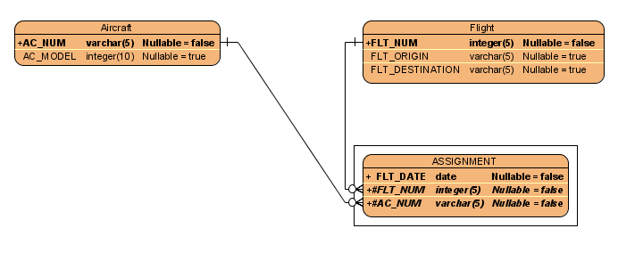

c) Draw the class diagram equivalent to the ERD above. Include multiplicity. Paste a screenshot of your result here:
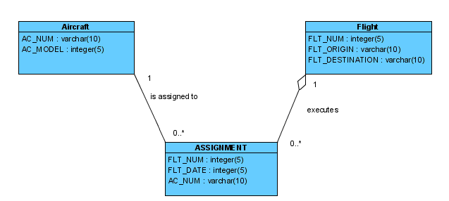

d) List business rules behind your association and multiplicity.
An aircraft can have 0 or more assignments.
An assignment can have only one aircraft.

A flight can have 0 or more assignments.
An assignment can only have one flight.

e) List the participation for each association
- It is optional for the aircraft to have an assignment. It is mandatory that each assignment be given to one airplane.
- It is optional that a flight be given an assignment. It is mandatory that each assignment be given to one flight.

Question 2 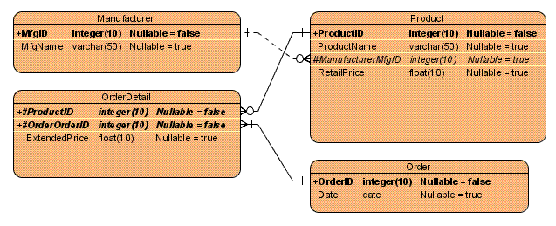
a) Are the relationships in this ERD strong or weak?
OrderDetail to Product and OrderDetail to Order are strong relationships because OrderDetail has a primary key that is based on the Product table and the Order table. In other words, OrderDetail is existence dependent on Product and Order. Therefore the relationship is strong.

Product to Manufacturer is a weak relationship. Both entities are existence independent.

b) Which entities are strong and which are weak? Why?
The Manufacturer, Product and Order tables are all strong as they are not dependent on other tables for their existence, their PK’ are self sufficient. The Order Detail table is weak because it uses the PK from both the Product and Order table for their definition/existence.

c) What changes are needed to this ERD to show strong vs. weak entities and strong vs. weak relationships?
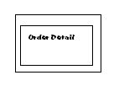

c) Draw the class diagram equivalent to the ERD above. Include multiplicity. Paste a screenshot of your result here:
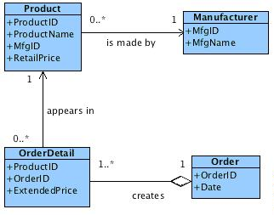

d) List business rules behind your association and multiplicity.
Manufactures supply zero to many products
Each product instance has only 1 manufacturer

An OrderDetail line shows only one instance of each product
Each Product can be associated with zero to many OrderDetails

An OrderDetail is associated with one and only one order
An Order must have at least one or more OrderDetail lines

e) List the participation for each association

OrderDetail is optional to Product, but Product is mandatory to OrderDetail.
Order is mandatory to OrderDetail.
Manufacturer is mandatory to Product, but Product is optional to Manufacturer.

Question 3
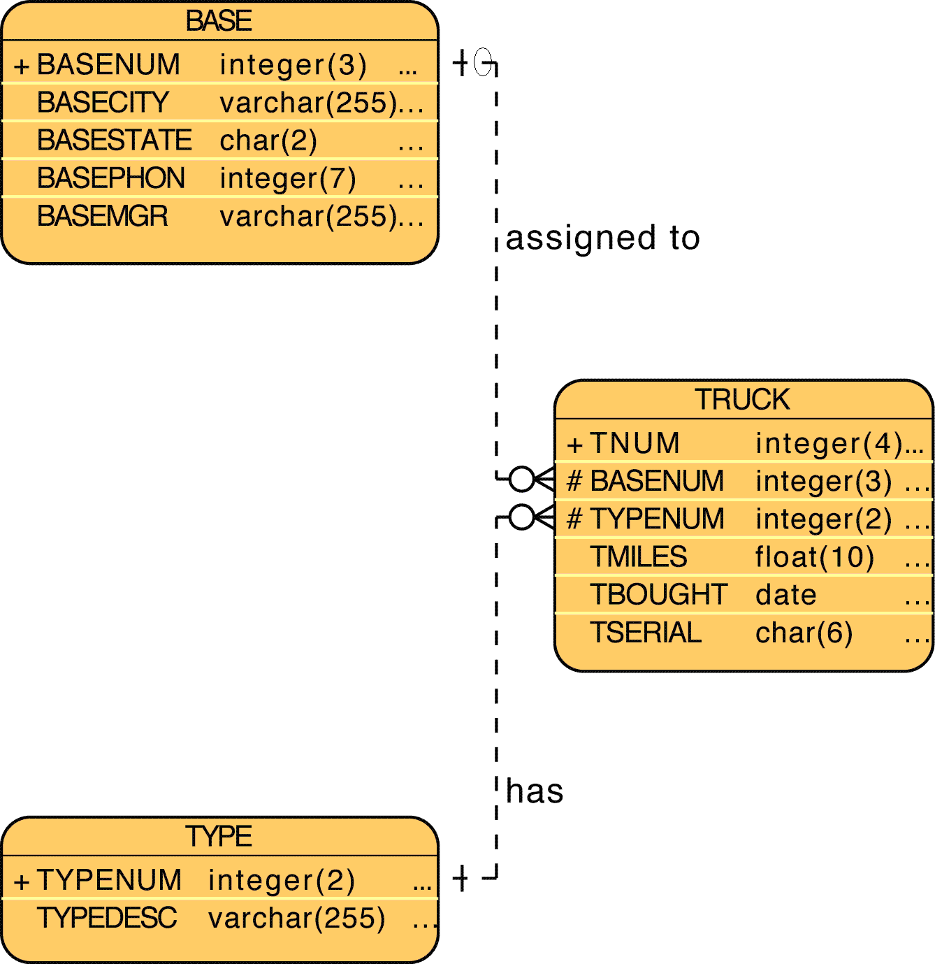

a) Are the relationships in this ERD strong or weak?
This relationships are weak because the PK for TRUCK is TNUM. Therefore TRUCK can exist independently of BASE and TYPE.

b) Which entities are strong and which are weak? Why?
BASE and TYPE and TRUCK are all strong entities. They can all exist independently because each entity has a primary key that does not include the PK of another entity.

c) What changes are needed to this ERD to show strong vs. weak entities and strong vs. weak relationships?
No changes are needed.

c) Draw the class diagram equivalent to the ERD above. Include multiplicity. Paste a screenshot of your result here:

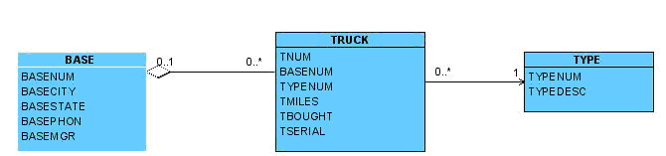

d) List business rules behind your association and multiplicity.
One base may have 0 to many trucks
0 or many trucks can be assigned to a base

A truck must only be classified as 1 specific type.
A type can be assigned to 0 to many trucks

e) List the participation for each association
Mandatory
A truck must have one type.

Optional
It is optional to assign a specific type to any truck.
It is optional to assign a truck to a base
It is optional for a base to have a truck.

Question 4
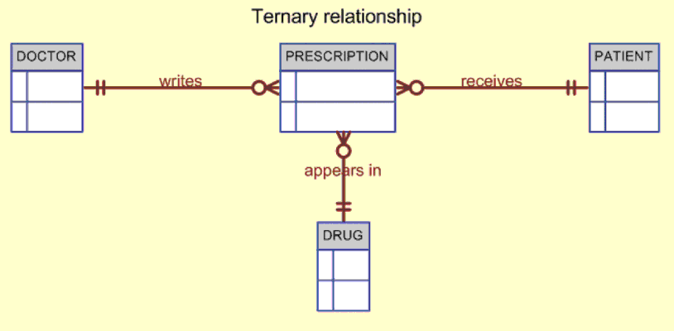

a) Are the relationships in this ERD strong or weak?
Assuming the primary key for PRESCRIPTION is derived from primary keys belonging to DOCTOR, DRUG, and PATIENT, we could then say all relationships shown are strong. We can say all relationships are strong in this case because PRESCRIPTION depends on the existence of all other entities to exist.

b) Which entities are strong and which are weak? Why?
Using the same assumptions in part a we can say PRESCRIPTION is a weak entity.

c) What changes are needed to this ERD to show strong vs. weak entities and strong vs. weak relationships?
The PRESCRIPTION entity can be drawn with a border around it. The relationships can remain as solid lines since all relationships are strong.

c) Draw the class diagram equivalent to the ERD above. Include multiplicity. Paste a screenshot of your result here: (Thank you Margarita)
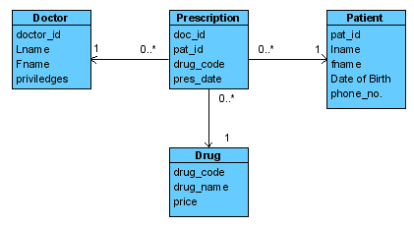
d) List business rules behind your association and multiplicity.
The doctor can prescribe 0 or many prescriptions. Each prescription can be written by only one doctor.
The patient can require 0 or many prescriptions. Each prescription is written for only one patient.
Each prescription can have only 1 drug. One drug can appear on 0 or many prescriptions.

e) List the participation for each association
It is optional for the doctor to write a prescription.
It is mandatory that the prescription be written by one doctor.

It is optional that the drug be issued in a prescription. However, it is mandatory that each prescription only have one drug.

It is optional for a patient to have a prescription. However it is mandatory for a prescription to be assigned to one patient only.

Question 5
Say you work for a company that operates several types of vehicles. Last time you counted, there were 23 different types of license classifications that your employees could have. Several employees have multiple types of vehicle licenses. To store this information in the employee table, the original database developer just kept adding more licence type columns to the employee table. What problem do you see with this practice? What is a proper way to get around this?

What problem do you see with this practice?
- There may be many employees with no license, yet each has a full set of license attributes which occupies unnecessary space.
- Changes to licensing requirements and standards requires maintenance of license columns.
What is a proper way to get around this?
Create a license entity to bridge employees and vehicle types.
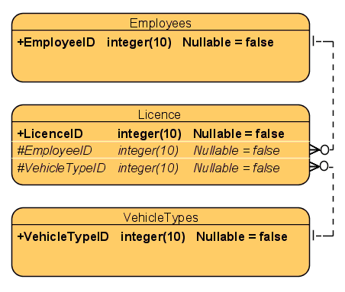Thank you Tony.

Part B: Preview (Please look up on the web)
Question 6
- Describe database normalization in 6 lines or less.
Database normalization is the process of organizing data into distinct and unique sets. The purpose of normalization is to:
- Reduce or eliminate storage of duplicate data
- Organize data into an efficient and logical structure
- What is 1st normal form. (6 lines or less)
Removal of repeating groups:
To eliminate duplicate columns from the same table. A row of data cannot contain repeating groups of similar data (atomicity) For example:

Student_Grade_Report(Studentno, student_name, major,course_no, course_name, instructor_no, instructor_name, instructor_location, grade) Becomes:

Student (Student_no,student_name,major)
Student_Course (Studentno, course_no, course_name, instructor_no,instructor_name, instructor_location, grade)

- What is 2nd normal form. (6 lines or less)
To be in 2nf, table must already be in 1st normal form and all partial dependencies must be removed. Partial occurs when a column partially dependent on a primary or candidate key but is not determined by the primary key. If a PK is not composite we can say it is already 2nf. Ie.

Student (Studentno,student_name,major)
Course_Grade (studentno,course_no,grade)
Course_Instructor(Course_no, course_name, instructor_no, instructor_name, instructor_location)

- What is 3rd normal form. (6 lines or less)
Removal of Transitive Dependencies

To be in 3rd Normal form, the table must already be in 2nd normal form and all columns that are not dependent on the primary key must be removed. For example:

Student (Studentno, student_name, major)
Course_Grade (Studentno, course_no, grade)
Course (Course_no,course_name,instructor_no)
Instructor (Instructor_no, instructor_name, instructor_location)

Question 7
What is a data warehouse? (4 lines or less)
A datawarehouse is a repository for historical data for essential record keeping and trend analysis. The data warehouse is designed to offer efficient performance to support queries that are used for making business decisions.

What is data mining? (4 lines or less)
Data mining is the process of extracting data to make forecasts and discover trends.

How is a data warehouse different than an operational database? (6 lines or less)
(Thank you Harry)
Operational | Warehouse
Small database | Large Database
Transaction oriented | Higher level business oriented
Up to date data | Historical data
Continuous updates | Batch updates
Normalized data | Denormalized data

Question 8
Draw a star schema. Explain the logic behind it and summarize how it helps in data warehousing. (12 lines or less)
Thank you Kathleen.
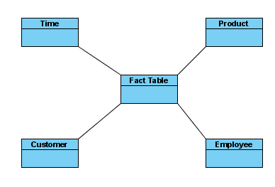

The star schema creates a virtually multidimensional database model from an existing relational database. The central fact table is related to the surrounding dimension tables through its composite primary key, which is derived from the primary keys of each dimension table. This design enables analysts to query the data across different dimensions (e.g. Summarize sales data for all products across time or summarize sales data for all employees across products). This design also enables analysts to query facts through the attributes of the smaller dimension tables, thereby facilitating data retrieval. Data warehouses can have many fact tables in order to capitalize on the efficiency of this design.
Submission Requirements
Due Tuesday January 29 at 10:00PM. Please submit everything in one document marked week3 discussion questions final. All group members must participate. List a summary of questions and persons responsible for each at the beginning of the document. List the name of the person who answered by each question. Split the questions evenly as possible (within reason).

